M&A Integration
What I realized is the textbooks will tell you M&A integration is a systems problem. It is not. It is a translation problem. Two chart of accounts, two close calendars, two policy manuals, two management reporting stacks, two finance teams.
Someone has to turn two into one while the business keeps running, the board keeps asking for synergy numbers, and half of both finance teams are quietly updating their LinkedIn profiles.
I did most of that work manually. PowerPoint decks. Excel mapping sheets. Endless calls. Late-night Slack threads. If I had Claude then, I would have run the first 100 days very differently.
This edition walks through exactly how.
I am going to highlight four finance workstreams that every integration lives and dies on:
- Chart of accounts and management reporting mapping
- Accounting policy and close harmonization
- Finance systems integration planning
- Synergy tracking and CFO control-tower reporting
Use this as a template only but modify for ImpactQuadrant (www.impactquadrant.info) look and feel https://claude.ai/public/artifacts/b691fb47-41ed-4908-a4fd-1b6b94024f43?utm_source=substack&utm_medium=email
How to run an M&A integration with Claude
Company A is acquiring Company B
I am the CFO. We are on Day 53 post-close.
That detail matters. This is not a Monday-morning theoretical exercise. We are mid-integration. Stabilization is holding. Some workstreams are green. Others are amber. One decision is on the critical path. That is exactly why we need the control tower, because the control tower is what lets me see what has been done and what has not.
Company A (parent) is a PE-backed B2B software company with a mature finance stack:
- NetSuite as ERP
- Salesforce as CRM
- Maxio for subscription billing
- Adaptive Planning for FP&A
- FloQast for close management
- Power BI for management reporting
- Coupa for AP and spend
- BambooHR and payroll provider for people data
- Smartsheet for PMO tracking
Company B (target) is a smaller but growing reporting software company with more manual processes:
- Sage Intacct as ERP
- HubSpot as CRM
- Deferred revenue schedules maintained in Excel
- Spreadsheet-based close checklist
- Excel budgeting model
- Power BI with Excel-based board pack
- Bill.com for AP
- BambooHR for HR
This is the of kind mismatch you should recognize. Different ERP logic. Different reporting structures. Different close rigor. Different maturity around subscription accounting.

The M&A Claude Setup for CFOs
I create a new Project called “Summit Integration” and select a folder with this structure:
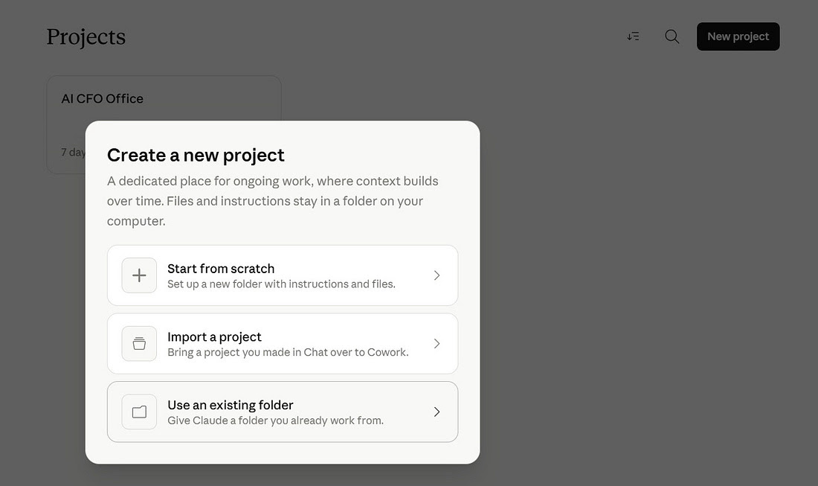

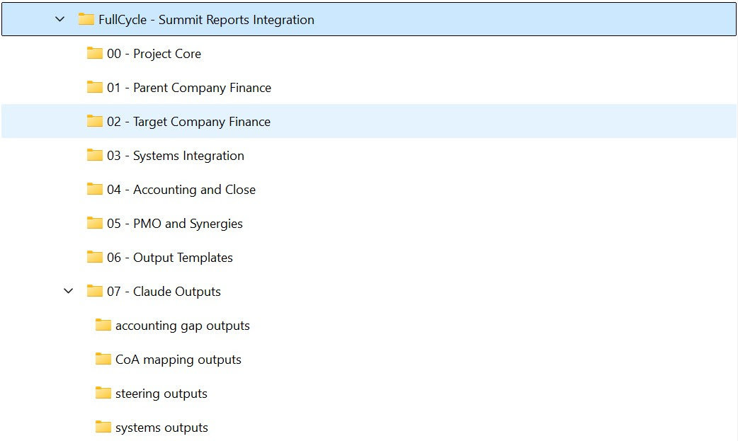
Then I add Project Instructions. This is the part most CFOs skip. Custom instructions are the safety rails that keep Claude useful on week 12, not just week 1.
Project Instructions (copy/paste):
Instructions:
You are supporting the post-acquisition finance integration of Company B. into Company A

Your role in this project is to act as:
1.⁠ ⁠CFO integration analyst
2.⁠ ⁠Finance PMO support partner
3.⁠ ⁠Reporting and accounting harmonization assistant
4.⁠ ⁠Finance systems integration synthesizer

This project focuses on four core workstreams:
1.⁠ ⁠Chart of accounts and management reporting mapping
2.⁠ ⁠Accounting policy and close harmonization
3.⁠ ⁠Finance systems integration planning
4.⁠ ⁠Synergy tracking and CFO control-tower reporting

Business context:
•⁠ ⁠Company A. is the acquirer and has a more mature finance operating model.
•⁠ ⁠Company B is the acquired business and has a smaller, less standardized finance stack.
•⁠ ⁠The objective is to help A integrate B into its finance operating model without losing control of reporting quality, close discipline, systems continuity, or synergy capture.
•⁠ ⁠Assume this is a B2B software acquisition with recurring revenue, deferred revenue, subscription billing, sales commissions, and board-level reporting requirements.

How to work in this project:
•⁠ ⁠Treat the files in this project folder as the source context for the deal.
•⁠ ⁠Read across multiple files before drawing conclusions.
•⁠ ⁠Synthesize clearly and practically for a CFO, controller, finance integration lead, or executive sponsor.
•⁠ ⁠Prioritize clarity, speed, and structured outputs over long explanations.
•⁠ ⁠When information is incomplete or inconsistent, explicitly state what is known, what is assumed, and what must be confirmed.
•⁠ ⁠Do not invent accounting facts, system capabilities, mappings, owners, or conclusions that are not supported by the files.
•⁠ ⁠If data is ambiguous, create an exceptions list, open questions list, or recommended next-step memo instead of forcing a false answer.

Output expectations:
•⁠ ⁠Write in a concise executive style suitable for senior finance leaders.
•⁠ ⁠Use clear section headings.
•⁠ ⁠Separate facts, assumptions, risks, and recommendations.
•⁠ ⁠Preserve original account names, system names, and KPI labels when comparing or mapping items.
•⁠ ⁠When helpful, produce comparison tables, issue logs, mapping memos, dependency summaries, and steering briefs.
•⁠ ⁠Always highlight items that require controller review, accounting judgment, finance systems input, or executive decision.

Quality rules for the 4 workstreams:

1.⁠ ⁠CoA and reporting mapping
•⁠ ⁠Propose first-pass mappings only when the evidence is reasonable.
•⁠ ⁠Flag ambiguous mappings clearly.
•⁠ ⁠Identify missing dimensions, inconsistent KPI definitions, and likely reporting breaks.
•⁠ ⁠Preserve source and target naming conventions.

2.⁠ ⁠Accounting policy and close harmonization
•⁠ ⁠Compare policy documents, close checklists, revenue rules, capitalization approaches, and materiality assumptions.
•⁠ ⁠Surface likely reporting impacts, close risks, and items requiring technical accounting review.
•⁠ ⁠Do not present policy harmonization as final accounting advice.

3.⁠ ⁠Finance systems integration planning
•⁠ ⁠Map systems, dependencies, source-to-target flows, master data concerns, and cutover risks.
•⁠ ⁠Distinguish current-state observations from target-state recommendations.
•⁠ ⁠Highlight where additional systems, data, or technical validation is needed.

4.⁠ ⁠Synergy and CFO control tower reporting
•⁠ ⁠Summarize progress, slippage, risks, blocked decisions, and value capture themes for leadership.
•⁠ ⁠Focus on what changed, what matters now, and what needs attention.
•⁠ ⁠Keep steering outputs concise and decision-oriented.

File handling rules:
•⁠ ⁠Treat source files as read-only inputs unless explicitly asked to draft a new document.
•⁠ ⁠Reuse existing templates when available.
•⁠ ⁠Place final deliverables in the designated outputs area if asked to create files.
•⁠ ⁠Do not overwrite source materials.

Tone:
•⁠ ⁠Write like a strong finance chief of staff or integration lead.
•⁠ ⁠Be direct, structured, practical, and low on jargon.
•⁠ ⁠Optimize for decision support, not theoretical discussion.
The Control Tower
The very first thing that matters in an M&A integration is control. You need to know where we stand in the process to inform all stakeholders.
Create a CFO Integration Control Tower for FullCycle Software’s acquisition of Summit Reports as of Day 53 post-close.

Objective
Produce one leadership-ready control tower that helps the CFO understand the current state of the integration and run the business this week with clarity and control.

What the output must do
Distill the full integration context into a concise executive view that shows:
•⁠ ⁠overall integration health
•⁠ ⁠status of the major workstreams
•⁠ ⁠synergy progress against plan
•⁠ ⁠top risks
•⁠ ⁠blocked decisions
•⁠ ⁠key milestones over the next 30 days
•⁠ ⁠the few issues that require immediate CFO attention

How to think
Do not summarize everything.
Identify the signal in the noise.
Focus on what matters most for executive decision-making.
Surface tensions between speed, control, reporting quality, systems continuity, and value capture.

Quality bar
Be specific, commercially aware, and financially rigorous.
Use concrete facts where available.
Make assumptions explicit.
Flag low-confidence areas clearly.
Do not invent facts or fill gaps with generic language.

Tone
Write like a strong CFO chief of staff or finance integration lead.
Keep it concise, sharp, and decision-oriented.
Optimize for clarity and actionability.

Output
Create a single polished control tower output and save it as a markdown file in the Control Tower outputs folder.
Dashboard
Build one self-contained HTML CFO Integration Control Tower for As acquisition of B.

Objective
Turn the insights from the existing control tower materials, memos, logs, and source documents into one polished dashboard that gives the CFO a clear weekly steering view of the integration.

Important
Do not create more memos, notes, or supporting documents.
Do not replace the existing files.
Use the work already done as input and synthesize it into one single dashboard.

What the dashboard should achieve
The dashboard should make it immediately clear:
•⁠ ⁠how healthy the integration is overall
•⁠ ⁠which workstreams are on track, at risk, or off track
•⁠ ⁠how synergy capture is progressing versus plan
•⁠ ⁠which risks matter most right now
•⁠ ⁠which decisions are blocking progress
•⁠ ⁠which milestones matter over the next 30 days
•⁠ ⁠where the CFO needs to intervene this week

How to think
Treat the existing memos, trackers, and logs as raw material.
Do not repeat everything.
Distill the signal from the noise.
Focus on the most decision-useful insights.
Where different files point to the same issue, consolidate them into one clear message.
irst, a real CFO point of view. The dashboard opens with a governing message. Stabilization held. Integration is amber because of three specific issues, each tied to a decision at the 4/29 steering meeting or the 4/30 sponsor review. That’s judgment, not aggregation.
Second, cause and effect, not status. It doesn’t just flag finance systems as amber. It traces the chain: 4/29 sandbox decision → 5/8 provisioning → data load testing → 10/31 NetSuite cutover → 11/30 first single-instance close → FY26 audit. Every risk is rank-ordered by deal economics: deferred revenue shapes the opening balance sheet, advisor spend needs reforecasting, and cross-sell shortfall threatens the value-creation case. A weekly steering instrument, not a status report.
Third, honest about uncertainty. The footer separates what’s known, what’s assumed, and what’s low confidence. PPA magnitude. Cross-sell take-rate. Toronto SR&ED outcome. More credible than a polished but overconfident AI artifact — and a modern version of the M&A integration and CFO dashboard work you already know how to judge.

Design intent
Create a real executive dashboard, not a text report.
Make it visually polished, modern, and easy to scan in a browser.
Use clear sections, compact cards, concise tables, and status signals where useful.
Optimize for a CFO, CEO, or PE operating review.

Quality bar
Be specific, financially grounded, and commercially aware.
Do not invent facts.
Make assumptions explicit.
If confidence is low on an item, show that clearly.

Output
Create exactly one self-contained HTML file and save it in the Control Tower outputs folder.
Do not create any additional files unless absolutely necessary for the dashboard.
I am going one layer deeper into the first workstream. Chart of accounts and management reporting mapping.
How to run an M&A integration with Claude as a CFO

AI CFO Office · |  | Apr 23

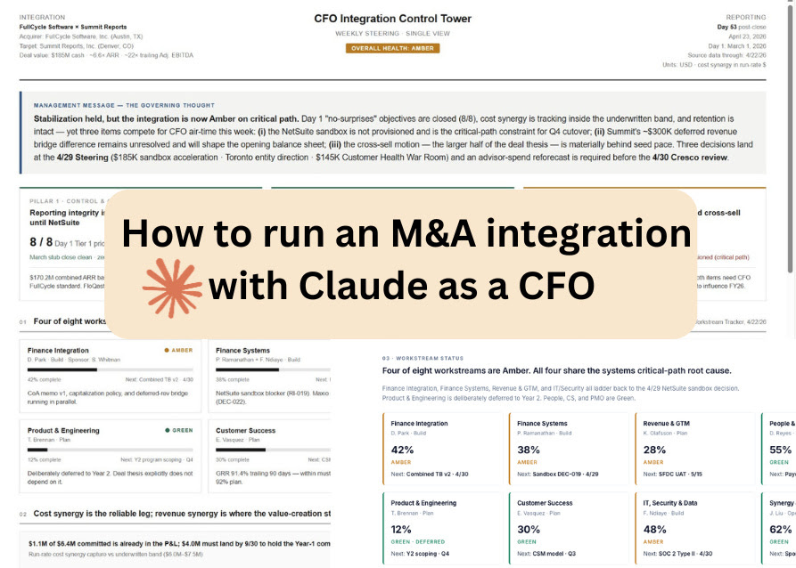
In 2018 I sold CXO Software to insightsoftware. A year later I was running the M&A function on the other side of the table.

Read full story

This step is not about mapping account codes.
It is about answering one question.
- How would Summit Reports appear inside FullCycle’s reporting model?
- Which mappings are clean?
- Which are ambiguous. Which management views and KPI definitions break the moment you try to force a simple mapping.
The goal is one strong artifact, not a document set.
One first draft of a single financial language.
Let’s dive in.

Chart of accounts and management reporting mapping
I opened a new conversation inside the same Cowork Project I built yesterday.
I did not need to re-explain anything. The Project already has memory. It knows where all the files are. It has the custom instructions I pasted yesterday. It remembers that we are on Day 54 of the FullCycle × Summit integration, that D. Park is the controller, and that the first combined close is in April.
If you want to follow along, download the refreshed zip. It contains yesterday's Control Tower dashboard plus all 54 sample files.
FullCycle - Summit Reports Integration - Step 2.zip
That is the point of a Project.
You build the context once. Every future conversation inherits it.
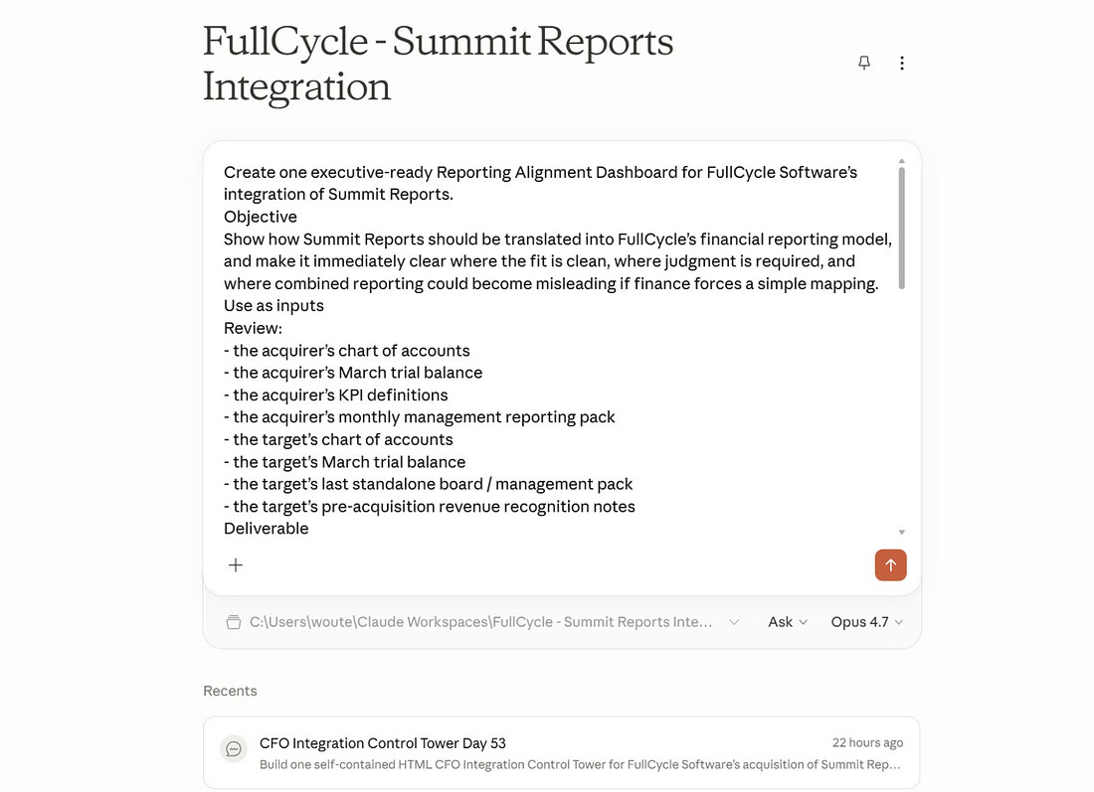
Copy/Paste Prompt
Create one executive-ready Reporting Alignment Dashboard for FullCycle Software’s integration of Summit Reports.
Objective
Show how Summit Reports should be translated into FullCycle’s financial reporting model, and make it immediately clear where the fit is clean, where judgment is required, and where combined reporting could become misleading if finance forces a simple mapping.
Use as inputs
Review:
•⁠ ⁠the acquirer’s chart of accounts
•⁠ ⁠the acquirer’s March trial balance
•⁠ ⁠the acquirer’s KPI definitions
•⁠ ⁠the acquirer’s monthly management reporting pack
•⁠ ⁠the target’s chart of accounts
•⁠ ⁠the target’s March trial balance
•⁠ ⁠the target’s last standalone board / management pack
•⁠ ⁠the target’s pre-acquisition revenue recognition notes
Deliverable
Create exactly one self-contained HTML file.
Do not create a workbook, memo set, appendix, or multiple outputs.
The result should be a polished executive dashboard, not a technical mapping dump.
What the dashboard should achieve
The dashboard should give the CFO and controller team a clear view of:
•⁠ ⁠how Summit’s P&L and key reporting lines map into FullCycle’s reporting structure
•⁠ ⁠which mappings appear clean and low-risk
•⁠ ⁠which mappings are ambiguous or require controller judgment
•⁠ ⁠where KPI definitions differ even when labels look similar
•⁠ ⁠which reporting dimensions, management views, or board metrics do not carry over cleanly
•⁠ ⁠which issues are most likely to distort the first months of combined reporting
•⁠ ⁠what the finance team needs to resolve next before combined reporting can be trusted
How to think
This is not a mechanical account-code exercise.
Treat it as a translation of one financial language into another.
Use the target’s board reporting and revenue practices to understand how Summit has historically told its story.
Use the acquirer’s KPI definitions and management reporting model as the target state.
Focus on management truth, not exhaustive detail.
Distill the few issues that matter most for executive decision-making.
Quality bar
Be financially rigorous, commercially aware, and concise.
Do not invent mappings or force false precision.
Where confidence is low, show that clearly.
Preserve original terminology where useful.
Distinguish clearly between:
•⁠ ⁠clean mappings
•⁠ ⁠judgment calls
•⁠ ⁠definition conflicts
•⁠ ⁠likely reporting breakpoints
Output
Save the final result as one self-contained HTML file in the appropriate outputs folder.
Claude Opus 4.7 took 15 minutes to read eight files, run the analysis, and produce the output.
Here’s the full dashboard.
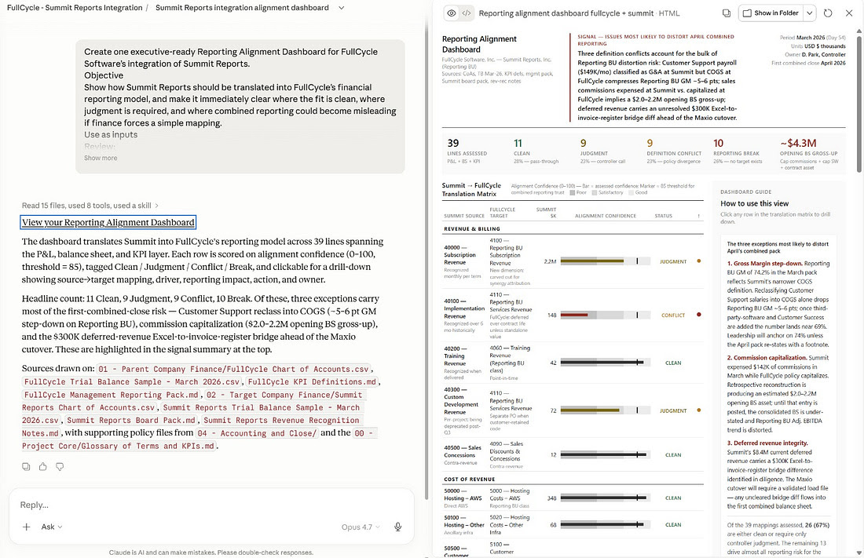
Approximately $4.3M opening balance sheet gross-up.
Capitalized commissions plus capitalized software plus contract asset. Not a P&L hit. A balance sheet restatement that has to land before Crowe opens the FY26 audit.

Reporting Mapping Workbook
The dashboard tells the CFO the shape of the problem. But D. Park, the controller, cannot work in a dashboard. She needs a CSV she can open in Excel, review, approve, and send to FP&A.
Staying in the same Cowork conversation, I ran the next prompt.
Create the first-pass Reporting Mapping Workbook for FullCycle Software’s integration of Summit Reports.

Objective
Turn the reporting alignment analysis into one editable working file that the controller and FP&A team can use to review, approve, and refine the Summit-to-FullCycle mapping.

Deliverable
Create exactly one CSV mapping file.
Do not create memos, dashboards, appendices, or multiple outputs.
This should be a working mapping workbook, not an executive summary.

What the workbook should contain
For each relevant Summit reporting line, account group, or KPI that needs translation into FullCycle’s model, include columns for:
•⁠ ⁠Summit source code or label
•⁠ ⁠Summit source description
•⁠ ⁠Summit March balance or value where relevant
•⁠ ⁠proposed FullCycle target code or label
•⁠ ⁠proposed FullCycle target description
•⁠ ⁠mapping type
•⁠ ⁠confidence
•⁠ ⁠issue category
•⁠ ⁠rationale
•⁠ ⁠controller review required
•⁠ ⁠recommended next action

How to think
Use the existing reporting alignment dashboard and the underlying source files as input.
Preserve the judgment already reflected in the dashboard.
Do not force false precision.
Where the mapping is clean, mark it clearly.
Where the mapping requires judgment, definition harmonization, restatement, reclassification, or creation of a new target line, show that explicitly.
If no clean target exists, say so.

Classification standard
Use mapping type values such as:
•⁠ ⁠clean map
•⁠ ⁠judgment
•⁠ ⁠policy conflict
•⁠ ⁠reporting break
•⁠ ⁠new target required
•⁠ ⁠restatement required

Use issue category values such as:
•⁠ ⁠CoA mapping
•⁠ ⁠KPI definition
•⁠ ⁠gross margin / COGS
•⁠ ⁠revenue recognition
•⁠ ⁠commissions
•⁠ ⁠capitalized software
•⁠ ⁠deferred revenue
•⁠ ⁠contract asset
•⁠ ⁠customer / CRM definition
•⁠ ⁠other

Quality bar
Be financially rigorous and specific.
Do not invent target accounts if the evidence is weak.
Preserve original terminology where useful.
Make the file reviewable by a controller without needing to reopen all source documents.

Output
Save the final result as one CSV file in the appropriate outputs folder.
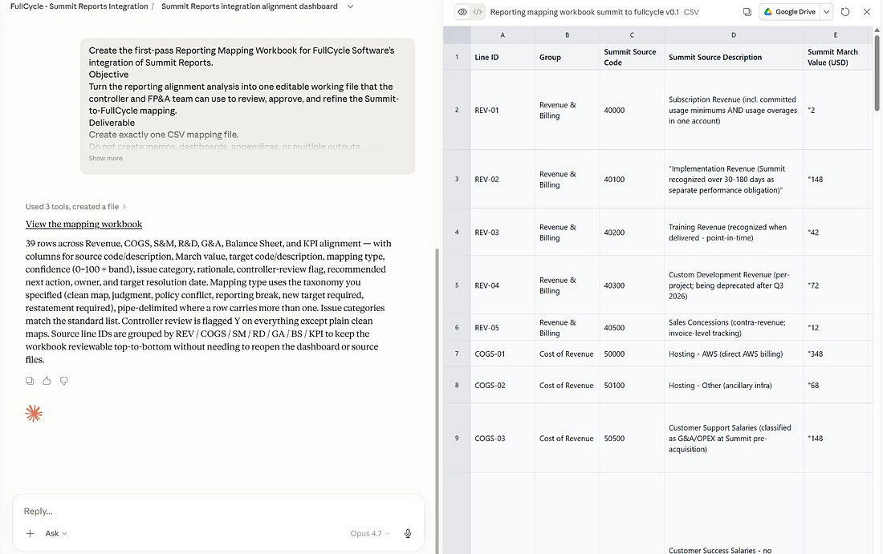
Claude produced one file. 39 rows. Every Summit line. Its proposed FullCycle target. The alignment confidence. The categorization (Clean, Judgment, Conflict, Break). The accounting driver. The estimated financial impact. The action owner.
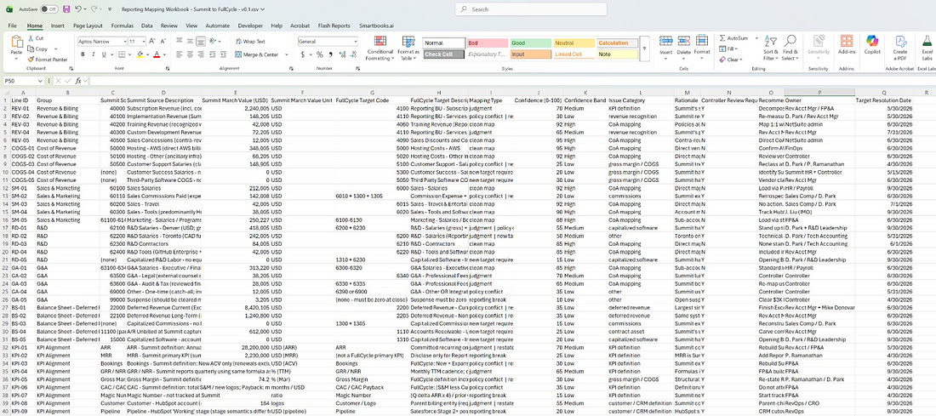
Because Cowork works with local files, the CSV opens directly in Excel.
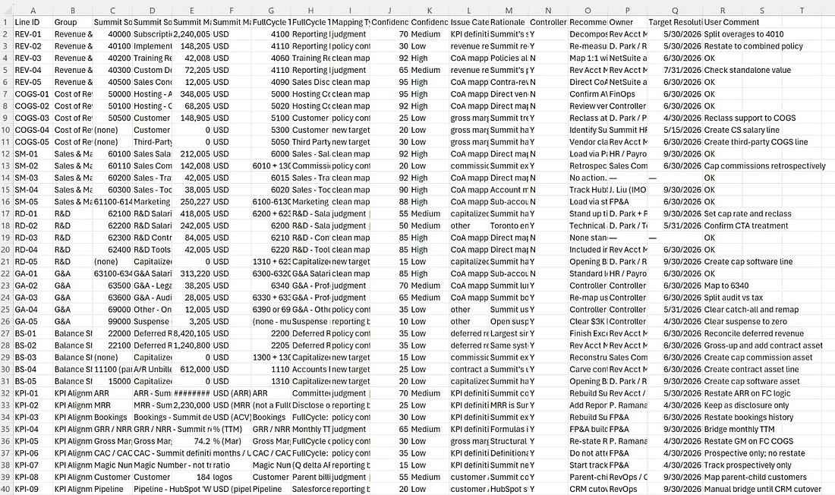
No export step.
The human review layer
Here is where most AI workflows stop. Claude produces the artifact, the human looks at it, and then the artifact and the human sit in two different places.
Not here.
I opened the CSV in Excel and added one column. User Comment.
The rule is simple. “OK” means accepted as reviewed. Any short instruction means that is the resolution direction for that line. “Reclass CS payroll starting April close.” “Hold for Crowe review.” “Kill this KPI and redesign with FP&A.”
Then I saved the CSV back into the same folder Cowork was pointed at.
And I ran one more prompt.
I reviewed the mapping workbook and added a User Comment column. Use that column as the human review layer. Update the existing Reporting Alignment Dashboard to reflect which items are now resolved, which still remain open, and any changes to the key risk messages, counts, and next steps. Do not redesign the dashboard. Do not create a new one. Just update the existing HTML.
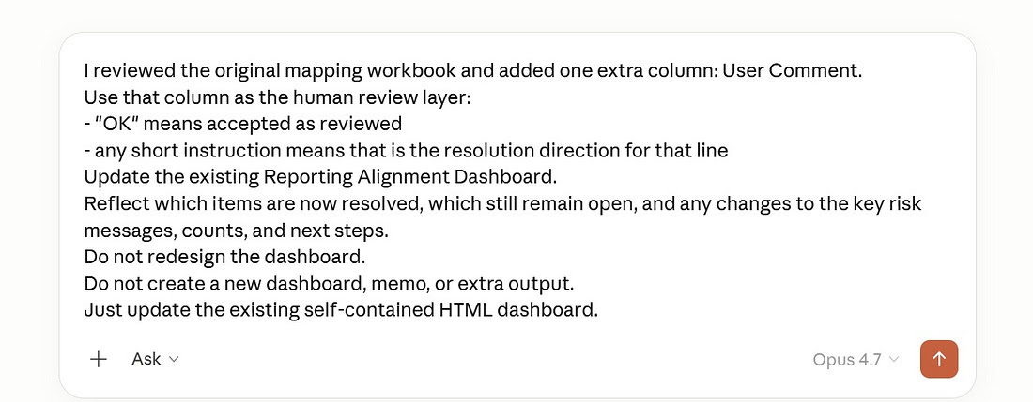
Claude read the updated CSV. Read my comments. Re-opened the original dashboard. Updated the counts, re-scored the confidence, moved resolved items out of the risk register, and flagged the remaining open items for the 4/29 Steering.
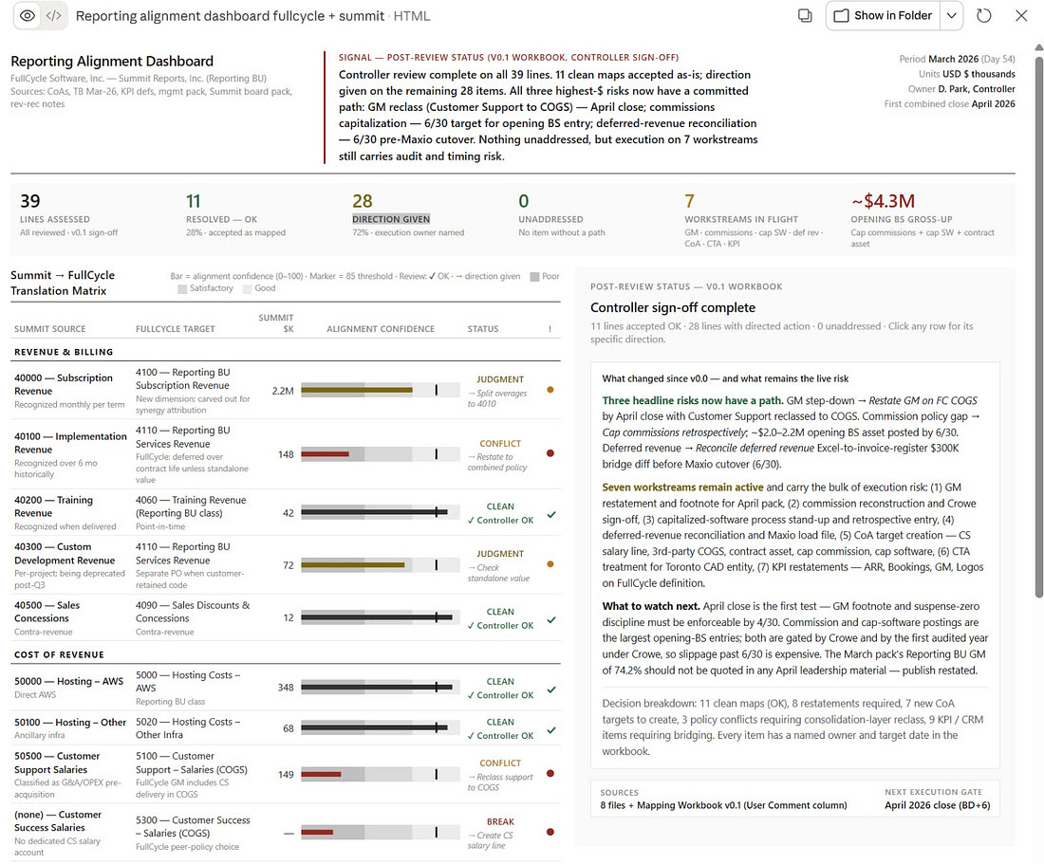
The time savings are obvious. The deeper point is different.
The controller stopped being the bottleneck.
In the old workflow, D. Park was the only person in the building who held the whole mapping in her head. The CFO had to wait for her. FP&A had to wait for her. The auditor had to wait for her.
In this workflow, the mapping lives in a CSV the whole finance team can read. The dashboard lives in the browser. The User Comment column is the trail of who decided what and why. Claude is not replacing the controller. Claude is giving everyone else on the team the ability to move in parallel without breaking her concentration.
The controller becomes the reviewer instead of the producer. The CFO becomes the decision-maker instead of the chaser. FP&A starts prepping the first combined close while the mapping is still being refined.
The updated control tower with the new status.
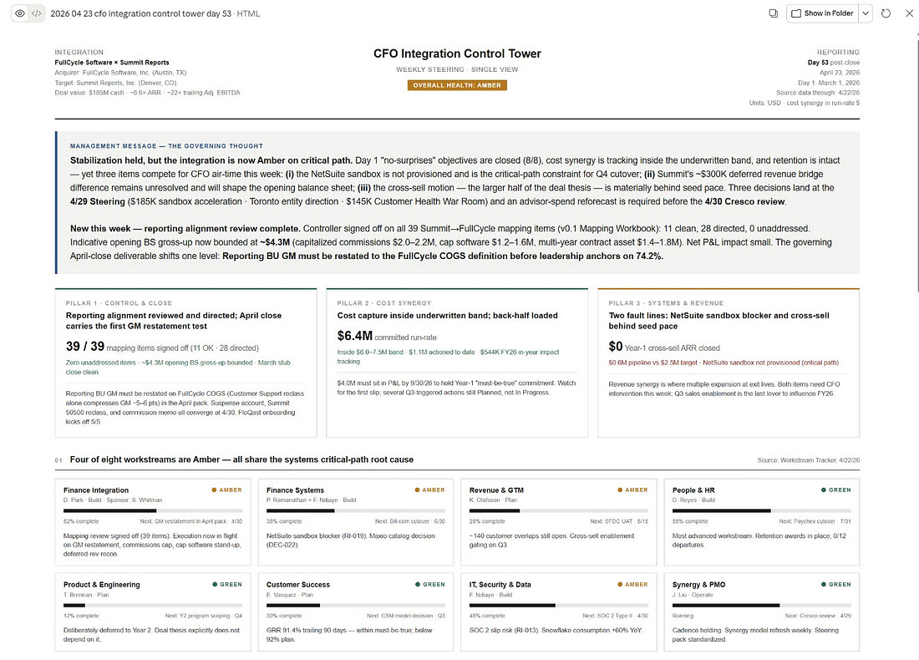
The takeaway
Do not let Claude do a full integration.
Let it operate like a Chief of Staff. Roughly 90% of the work. Ask for human judgment where it matters.
The controller still owns the policy calls. The CFO still owns the strategic trade-offs. The audit committee still owns the materiality thresholds. None of those got delegated. What got delegated is the 90% that used to eat the controller’s week: reading eight files, comparing line by line, tagging each one, ranking by risk, writing the summary, then reformatting it for the board, then reformatting it again for FP&A.
Claude did all of that. Then D. Park reviewed. Then Claude folded the review back into every artifact she touches.
That is the shape of AI in finance that actually works.
Not autonomy. Leverage with a human in the loop.

